Software Requirement Specifications (SRS)
INVENTORY MANAGEMENT SYSTEM



Submitted By
Muhammad Arham
(F22BINFT1M01160)
Supervisor
Ms. Sara Farid

Department of Information Technology
Faculty of Computing
The Islamia University of Bahawalpur

Table of Contents
1. Introduction 1
1.1 Objectives 1
1.2 Project boundaries 1
1.3 References 1
1.4 Overview 1
1.5 Definitions, Acronyms, and Abbreviations 2
2. The Overall Description 3
2.1 System Context: 3
2.1.1 Main advantages: 3
2.1.2 Daily Activities: 3
2.1.3 Deployment Needs: 3
2.1.4 Core Features: 3
2.2 User Profiles: 4
2.2.1Owner / Administrator 4
2.2.2 Employee / Cashier 4
2.2.3Assumptions 4
3. Detail Requirement 4
3.1 User Interface Requirements 4
3.1.1 Owner Panel 4
3.1.2 Employee Panel: 5
3.1.3 Hardware Needs: 5
3.1.4 Development Environment: 5
3.2 Functional Requirements: 5
3.3 Use Cases (How user will interact with the system) : 6
3.4 Classes / Objects: 7
3.5 Data Flow Diagrams (DFDs): 7
3.5.1 Level 0 Data Flow Diagram 8
3.5.2 Level 1 Data Flow Diagram 9
2.5.3 Level 2 Data Flow Diagram 10
3.6 Non-Functional Requirements 11
3.7 Logical Database Requirements 12
3.8 Design Constraints 12
3.8.1 Standards Compliance 12

1. Introduction

1.1 Objectives
The Inventory Management System is a modern web platform created to simplify and improve the control over stock levels, customer sales, and supplier purchases in retail outlets. Its core aim is to replace paper-based methods, eliminate mistakes, and raise daily efficiency through smart automation. This solution is built especially for small and medium retail shops to help them run smoother operations and achieve stronger results.

1.2 Project boundaries
This browser-based application offers one central place to handle stock monitoring, transaction recording, and procurement activities. The coverage includes
- Unified dashboard for all store activities.
- Protected entry according to user roles.
- Live statistics and instant report creation.
- Designed mainly for small to medium businesses.

1.3 References
https://www.slideshare.net/
www.google.com
www.w3schools.com

1.4 Overview
This specification explains all functional and non-functional needs, architecture guidelines, and development roadmap for the Inventory Management System so that developers and stakeholders share the same vision.
Key capabilities:
- Safe login and session control.
- Full product and stock oversight.
- Sales and buying workflow support.
- Detailed analytics and printable summaries.
Focus is placed on simplicity, growth potential, and user comfort.

Abbreviation | Definition
SRS | Software Requirements Specification: Software Requirements Specification (SRS) refers to the formal document that defines what the software under development should do, covering its functional behavior, performance, performance, security, and safety aspects
DFD | A Data Flow Diagram (DFD) is a graphical representation that illustrates how data moves through a system.
WCAG | WCAG stands for Web Content Accessibility Guidelines. It is a set of technical standards created by the W3C to make web content more accessible to users with various disabilities.
RAM | Random Access Memory (RAM) is high-speed volatile memory used by the computer to store data and instructions required for immediate processing and efficient operation.
SQL | SQL (Structured Query Language) is a domain-specific language used for creating, reading, updating, and deleting data in relational databases.
ISO | International Organization for Standardization
POS | Point of Sale : It denotes the moment and place at which a purchase or sale transaction is completed at the retail counter.
PHP | PHP: Hypertext Preprocessor: It is a popular programming language created with web development in mind.
XAMPP | It refers to a free, open-source, cross-platform package known as a web server solution stack, provided by Apache Friends, which consists of the Apache HTTP Server and MariaDB database.

1.5 Definitions, Acronyms, and Abbreviations

2. The Overall Description
The system works as an all-in-one online tool that automates and upgrades routine retail tasks covering stock handling, checkout processes, ordering from suppliers, and performance reviews.

2.1 System Context:
It is a self-contained web solution ideal for small and medium stores, combining stock control, sales tracking, purchase records, and reporting without needing extra programs.

2.1.1 Main advantages:
- Works in any updated browser.
- Single reliable database with immediate updates.
- Ready to grow together with the business.

Daily Activities:
- Recording customer payments and printing bills while reducing stock instantly.
- Checking stock regularly, receiving low-stock warnings, and planning reorders.
- Helping buyers, managing returns or swaps.
- Every employee must log in securely; administrators watch user actions.

2.1.3 Deployment Needs:
- Only administrators may change core settings.
- Works perfectly on Chrome, Firefox, and Edge.
- Clear screens designed for each role.
- Automatic nightly backups managed by admin.

2.1.4 Core Features:
- Stock Handling.
- Live quantity tracking and automatic alerts when items run low.
- Create, modify, or remove products.
- Group items into categories.
- Checkout Module.
- Bill storage and sales history.
- Procurement Module.
- Raise orders to vendors and follow their status.
- Update stock automatically when goods arrive.
- Analytics Section.
- Reports on revenue, stock status, and spending
- Export to PDF or Excel
- Access & Security
- Different permission levels (Owner / Employee)
- Strong password system (future two-factor option)

2.2 User Profiles:

2.2.1Owner / Administrator
- Adjust store information, taxes, etc.
- Add or remove staff accounts and set their rights
- Full control over products, sales history, and reports
- Manage backups and security rules

2.2.2 Employee / Cashier
- Ring up sales and print receipts
- Check current stock during customer service
- Handle approved returns
- Restricted menu according to store policy
- 2.4 Limitations
- Needs constant internet connection
- Best viewed on desktop screens (mobile view limited in first version)
- No direct link to external accounting packages at launch

2.2.3Assumptions
- Reliable internet at the store
- Users have modern computers and browsers
- Basic equipment present (PC, barcode reader, receipt printer)

3. Detail Requirement

3.1 User Interface Requirements

3.1.1 Owner Panel
- Staff account and permission control
- Product catalogue maintenance
- Advanced reporting and settings area

3.1.2 Employee Panel:
- Quick POS screen with barcode scanning
- Instant receipt printing
- Fast product search

3.1.3 Hardware Needs:
- CPU 1.6 GHz or better
- 4 GB RAM minimum
- Internet connection
- At least 350 MB free disk space

3.1.4 Development Environment:
- Editor: Visual Studio Code
- Server: XAMPP (Apache + PHP + MySQL)

3.2 Functional Requirements:
- Full create/update/delete for items and stock
- Automatic stock change after every sale or receipt
- Invoice creation and permanent storage
- Supplier records and purchase order tracking
- Secure role-based login
- Flexible reports on demand

3.3 Use Cases (How user will interact with the system) :
Use cases capture the step-by-step interaction between users and the system to achieve specific business goals while validating functional requirements.

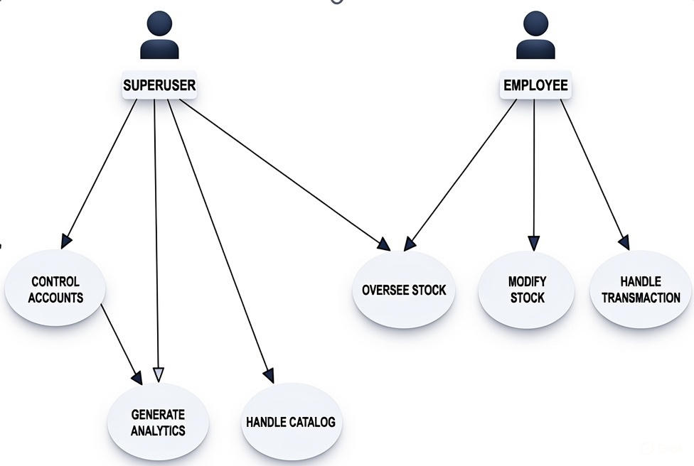

Figure 3.3: Use Cases

3.4 Classes / Objects:
This section contains major classes of the INVENTORY MANAGEMENT SYSYTEM.
A class in a class diagram is usually represented as a rectangle divided into three sections:
- Top Section: Class Name
- Middle Section: Attributes
- Bottom Section: Methods
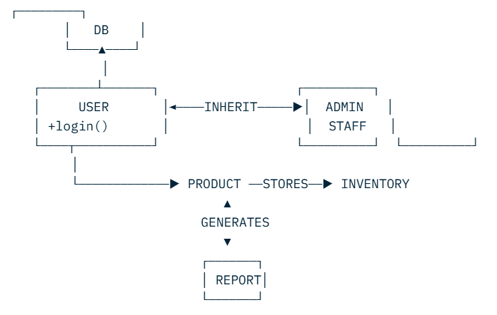

Figure 3.4.1: Class Diagram

3.5 Data Flow Diagrams (DFDs):
A Data Flow Diagram is a visual representation of how data moves through a system. It enhance understanding and help in identifying new issues while creating a new system.

3.5.1 Level 0 Data Flow Diagram
The Level-0 DFD, also referred to as the Context Diagram, presents an overall picture of the system. It depicts the system as a single central process and highlights the interactions and data exchanges with external entities (actors), while omitting internal details and data stores.

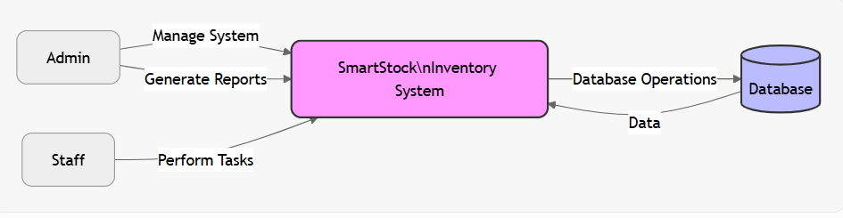

Fig 3.5.1: 0 Level DFD

3.5.2 Level 1 Data Flow Diagram
A Level-1 Data Flow Diagram expands the high-level process of the Level-0 DFD by breaking it down into primary subprocesses. It shows detailed internal data flows and emphasizes the system’s inner functionality.

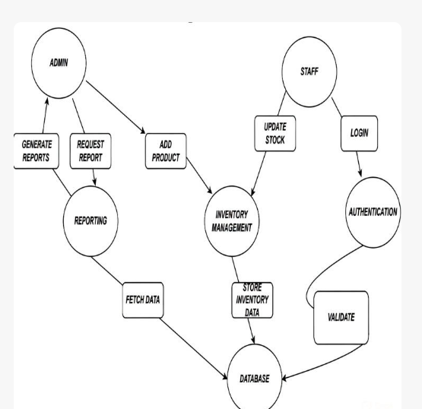

Fig 3.5.2: 1 Level DFD

2.5.3 Level 2 Data Flow Diagram
The Level-2 DFD zooms into a single subprocess identified in the Level-1 diagram, revealing its inner workings. It illustrates the finer-grained operations and data flows inside that subprocess and can include extra data stores and interactions.

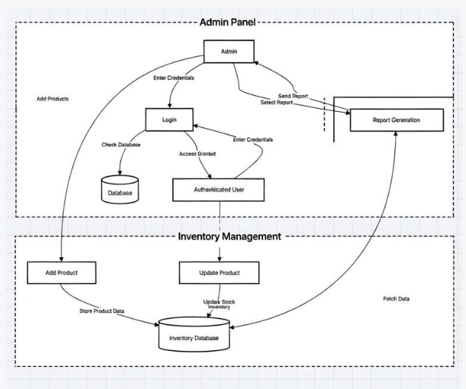
Fig 3.5.3: 2 Level DFD

3.6 Non-Functional Requirements
Non-Functional Requirements
- Usability: The system shall provide an intuitive and user-friendly interface that enables users of all experience levels to perform tasks efficiently with minimal training.
- Performance: The system shall deliver response times of less than 5 seconds for all user interactions and critical operations, even under peak transaction loads.
- Scalability: The system shall support seamless horizontal and vertical scaling to accommodate growing numbers of users, data volume, and transaction throughput without degradation in performance.
- Security: Sensitive data shall be protected through end-to-end encryption, role-based access control (RBAC), secure authentication mechanisms, and full compliance with applicable data protection regulations (e.g., GDPR, CCPA).
- Reliability: The system shall achieve at least 99.9% availability (measured monthly), with automated daily backups and a documented disaster recovery plan ensuring data restoration within 4 hours in case of major incidents.
- Maintainability: The system shall be designed with modular, well-documented, and loosely coupled components to facilitate future enhancements, bug fixes, and technology upgrades with minimal effort.
- Compliance: The system shall fully comply with all relevant legal and regulatory requirements, including financial, tax, invoicing, and industry-specific standards applicable to the business jurisdiction(s).
- Portability: The system shall be fully functional and consistently usable across major platforms and devices, including desktop browsers (Windows/macOS/Linux), tablets, and mobile devices (iOS and Android).
- Accessibility: The system shall conform to WCAG 2.1 Level AA standards, ensuring usability for people with disabilities, including support for screen readers, keyboard navigation, and sufficient color contrast.
- Backup and Recovery: The system shall perform automated, encrypted daily backups with point-in-time recovery capabilities and maintain a tested disaster recovery procedure to restore full operations within defined recovery time objectives (RTO) and recovery point objectives (RPO).

3.7 Logical Database Requirements
The inventory management system demands a robust and well-structured database to guarantee data accuracy, protection, high performance, and future growth while fully supporting day-to-day business activities.
Key database design principles applied:
- Architecture: Fully relational design relying on primary and foreign key constraints to maintain referential integrity.
- Core objects: Covers all essential areas — staff accounts, product catalog, sales records, stock levels, vendor details, and analytical reporting.
- Field types: Carefully chosen data types (e.g., character strings via VARCHAR, whole numbers via INT, dates via DATE/DATETIME, monetary values via DECIMAL) to optimize storage and speed.
- Normalization level: Schema is normalized to at least Third Normal Form (3NF), eliminating redundancy and preventing update anomalies.

3.8 Design Constraints

3.8.1 Standards Compliance
Regulatory and Industry Compliance Obligations
- Card Payment Security Every component involved in accepting, processing, or storing payment card information shall fully adhere to the latest Payment Card Industry Data Security Standard (PCI DSS) requirements.
- Management System Certifications The overall development, operational, and quality assurance processes must follow the guidelines of ISO 9001 (Quality Management) and ISO/IEC 27001 (Information Security Management System).
- Personal Data Protection The platform shall remain fully compliant with the General Data Protection Regulation (GDPR), providing robust safeguards for personal data, transparent processing notices, and full support for data-subject rights including access, correction, deletion, restriction, portability, and objection.
- Inclusive Design & Accessibility All user-facing interfaces (web portals, mobile apps, and printed/digital receipts) must satisfy Web Content Accessibility Guidelines (WCAG) 2.1 Level AA success criteria to guarantee usability for individuals with visual, auditory, motor, or cognitive impairments.
- Third-Party Integration Governance Connections to external systems—payment providers, shipping carriers, accounting tools, or any other service—must use industry-standard, well-documented APIs, enforce mutual TLS encryption, implement OAuth 2.0 or equivalent authentication, include proper timeout/retry logic, and respect rate limits.
- Taxation & Fiscal Compliance The solution must automatically apply correct local tax rates, produce legally valid invoices and credit notes, maintain immutable audit trails for all financial transactions, and generate statutory sales and tax reports in the exact format required by regional revenue authorities.
- Secure Development Lifecycle All code must be written according to recognized secure coding standards (e.g., OWASP Top Ten mitigation techniques, CERT secure coding rules), include comprehensive inline documentation, undergo regular static and dynamic security testing, and follow version-controlled, peer-reviewed release processes to ensure long-term maintainability and security.

